PhishGuard
HACK-O-WEEK | WEEK 13-14
Context API, State Management, and Styling

Section 1: Title
Hack-O-Week • Week 13-14 • Context API, State Management, and Styling. This report connects the college assignment to the inspected PhishGuard source code.

Section 2: Objective
Describe where PhishGuard state lives, how components exchange it, and how its actual CSS approach differs from common React styling options.

Section 3: Theory
State patterns. Keep state near the components that use it. Lift shared state to a common parent and pass data down with props and callbacks up. Prop drilling becomes awkward when many intermediate layers pass values they do not use.
Context API. A provider makes a value available to descendants; useContext reads it. Context suits broadly shared, relatively stable values such as theme or session state. It does not remove the need to design updates carefully.
Styling approaches. CSS Modules scope class names to a module. Tailwind uses utility classes in markup. styled-components defines styles alongside components through a library. Regular CSS uses shared selectors and custom properties.

Section 4: Implementation in PhishGuard
App stores browser scan history and the rescan request. URLScanner owns current URL, result, loading, error, and demo visibility. ScanHistory owns only its search query. App passes history and callbacks through props, so no Context API or external state library is currently used. The frontend imports Tailwind 4 and the Vite plugin, but its visible UI styling is primarily frontend/src/index.css with standard CSS selectors and tokens. It does not use CSS Modules or styled-components.

Section 5: Code Explanation
Parent-owned history and prop flow
Source: frontend/src/App.jsx
Actual implementation. App owns shared state and passes it to children through props. This is simple state lifting, not Context API. The corresponding code is in this week’s companion Code_Examples.md file.
Local scan state
Source: frontend/src/components/URLScanner.jsx
Actual implementation. State that serves only the scanner stays inside URLScanner; history is shared at App level. The corresponding code is in this week’s companion Code_Examples.md file.
Actual styling tokens
Source: frontend/src/index.css
Actual CSS variables and Tailwind import. The application uses regular global CSS as its primary styling. Tailwind is configured, but CSS Modules and styled-components are absent. The corresponding code is in this week’s companion Code_Examples.md file.
Context and styling alternatives
Source: Educational example (not in PhishGuard)
Educational comparison. Context and the three style syntax examples illustrate assignment approaches; they are not implemented in PhishGuard. The corresponding code is in this week’s companion Code_Examples.md file.

Section 6: Working Flow
- App loads and owns shared scan history.
- URLScanner owns transient form and analysis state.
- The scanner passes new history upward through onNewResult; App passes records and actions down.
- Global CSS variables and selectors style the composed views; responsive media queries adapt layouts.

Section 7: Learning Outcome
The current app uses local state and parent props for shared scan history. Its styling is primarily regular CSS with custom properties; Context API, CSS Modules, utility classes, and styled-components can be chosen for different scaling and team needs.

Section 8: Code Implementation Screenshots
Captured from the project source file open in Visual Studio Code. Captions identify the displayed file. Code examples are in the companion Code_Examples.md file, not in this Word report. Educational examples there are labeled and are not application code.
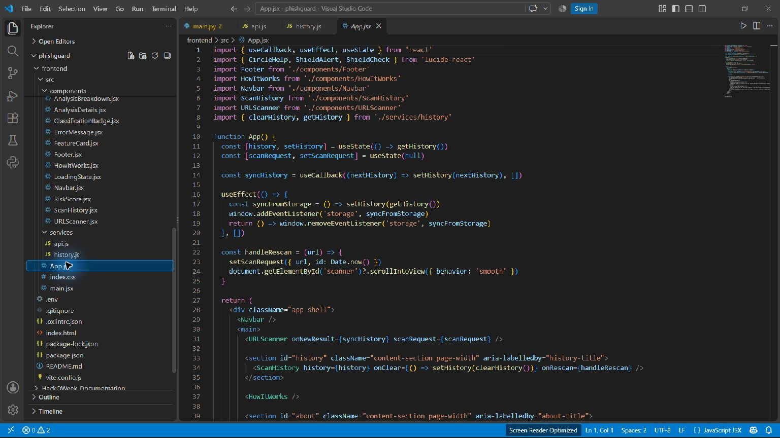
App history state and parent-to-child props — frontend/src/App.jsx
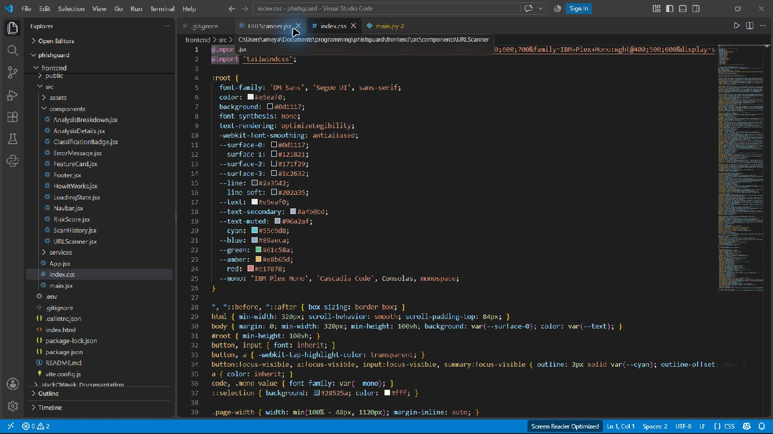
CSS variables and Tailwind import — frontend/src/index.css

